Alarm: Cannot Enter System

How To Fix:
This alarm occurs when the AGV is not correctly aligned on its path.
Figure
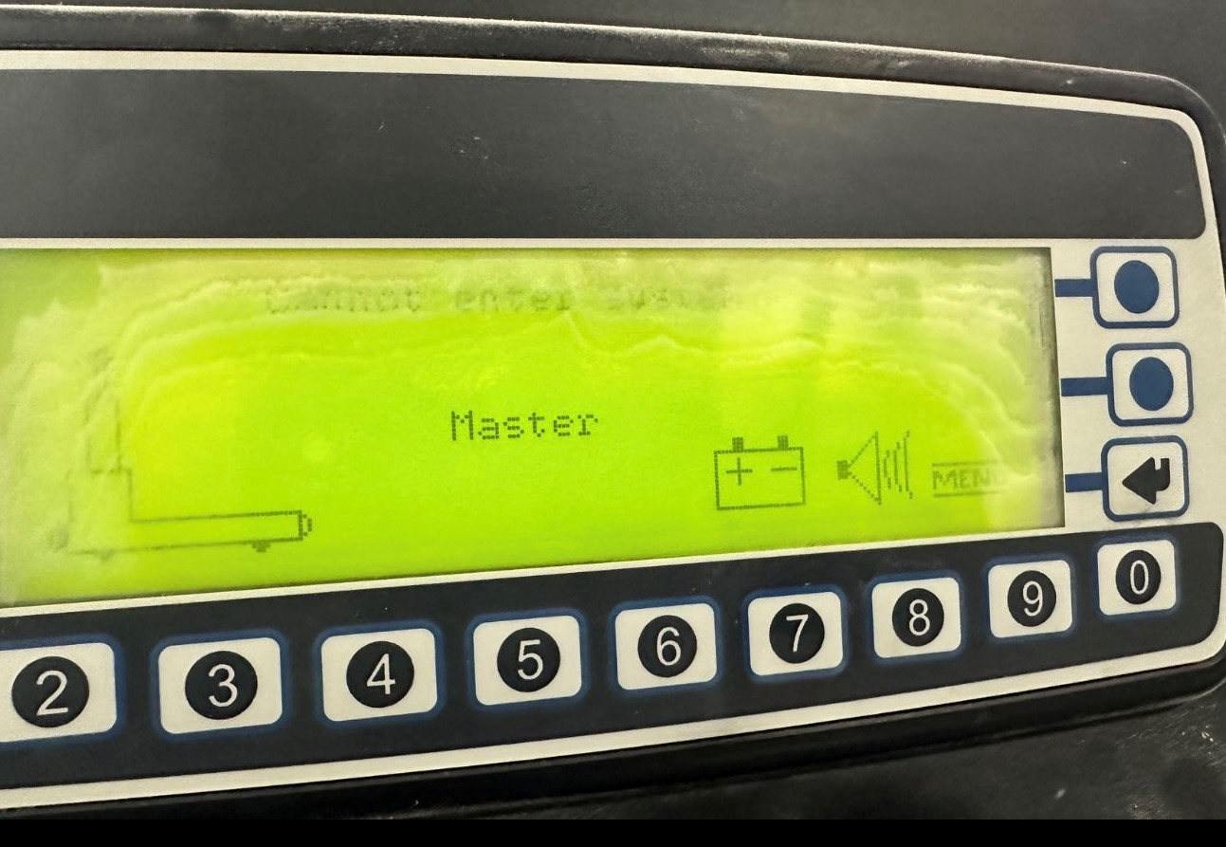
To resolve:(two steps)
- Drive the AGV toward the center of the path, ensuring it is facing the correct direction.
- Restart the AGV using the automatic sequence:
  - Switch to Automatic Mode
  - Press the Blue button
  - Press the Green button

